**COVID-19 Death Trends and 7-Day Progression Analysis: Bangladesh, India, Sweden, and the United States**

**Objective:** This project examines the trends of COVID-19-related deaths in Bangladesh, India, Sweden, and the United States by analyzing the 7-day progression of death counts to better understand the pandemic's impact and progression in these diverse countries.

**Data:** The dataset includes daily reported COVID-19 deaths for Bangladesh, India, Sweden, and the United States, along with computed 7-day moving averages to smooth out daily fluctuations and reveal clearer trends.

**Methods:**

* Calculated the 7-day moving average of daily deaths for each country to identify trend patterns.
* Used line charts to visualize and compare death trends and progression rates between the four countries.
* Analyzed peaks and declines to understand the timing and severity of different COVID-19 waves.

**Key Findings**:

India and the United States showed distinct multiple waves with significant peaks in death counts, reflecting severe COVID-19 surges.

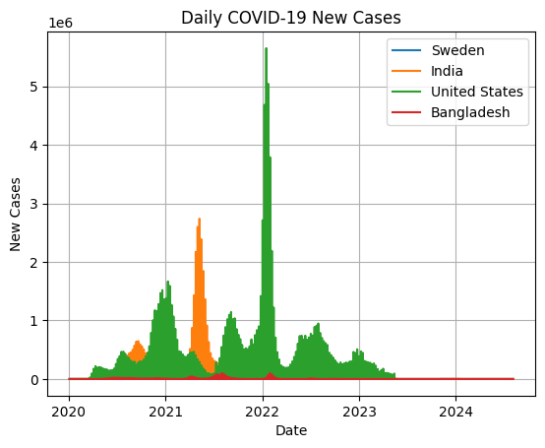

Bangladesh exhibited a more gradual progression with smaller peaks, while Sweden’s trends showed earlier waves followed by more stable death rates.

The 7-day progression smoothing helped reveal these trends more accurately by reducing daily reporting noise.

Variations in trends highlight differences in healthcare infrastructure, government interventions, population density, and public health responses.

**Conclusion:** This comparative analysis, which tracks a 7-day progression of COVID-19 deaths, highlights the varying impacts of the pandemic across Bangladesh, India, Sweden, and the United States. Understanding these trends supports better preparation and response strategies for future outbreaks.